How to do Programming Assignment 1

Programming Assignment 1 (PA1) is to write a lexical analyzer, also called scanner using a lexical analyzer generator, flex.

The tasks of PA1:

1. Write Flex rules that match on the appropriate regular expressions defining valid tokens in Cool
2. Perform the appropriate actions:

* Returning a token
* Recording the value of a lexeme
* Reporting an error when an error is encountered

How to do:

1. Go to course website and read the instruction of PA1. Download the Assignment 1 PDF.

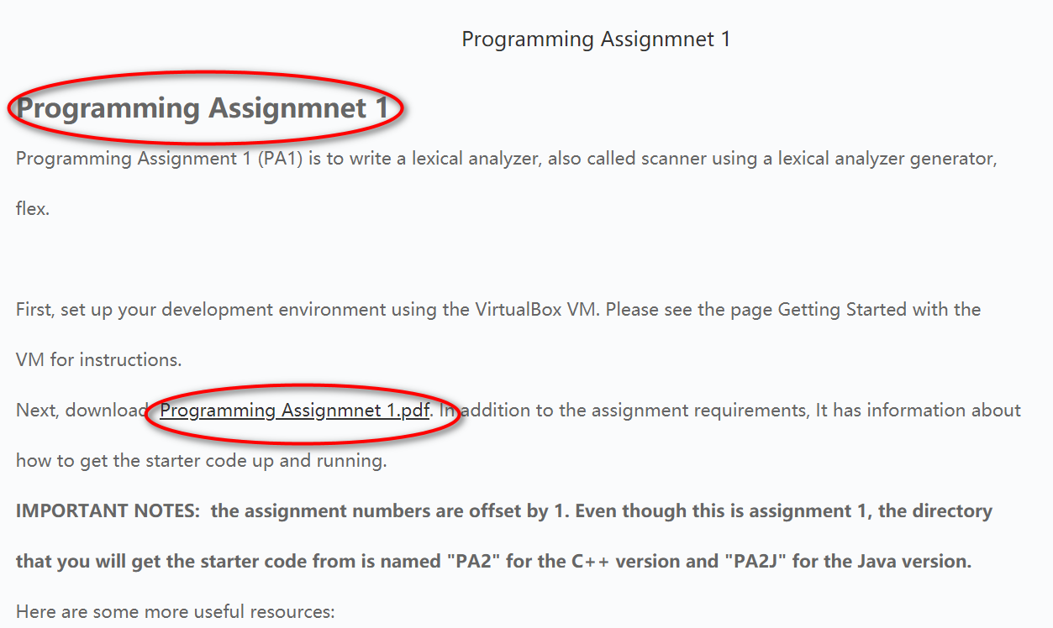

1. To get started, create a directory where you want to do this assignment. For example, create a directory named “myPA1”

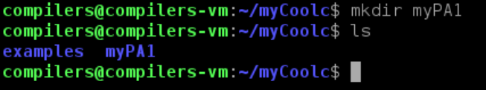

In “myPA1” directory, execute the following command to get the start code

“make -f /usr/class/cs143/assignments/PA2/Makefile”

Note: even though this is the first programming assignment, the directory name is PA2. Future assignments will also have directories that are one more than the assignment number–please don’t get confused!

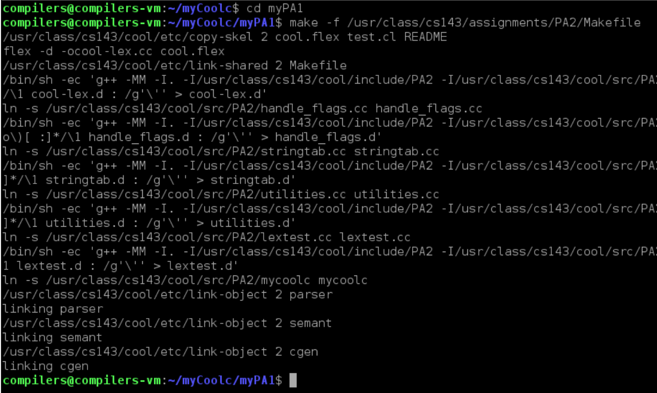

This command will copy a number of files to your directory as the starter code.



1. Read the README file. This file contains detailed instructions for the assignment as well as a number of useful tips.

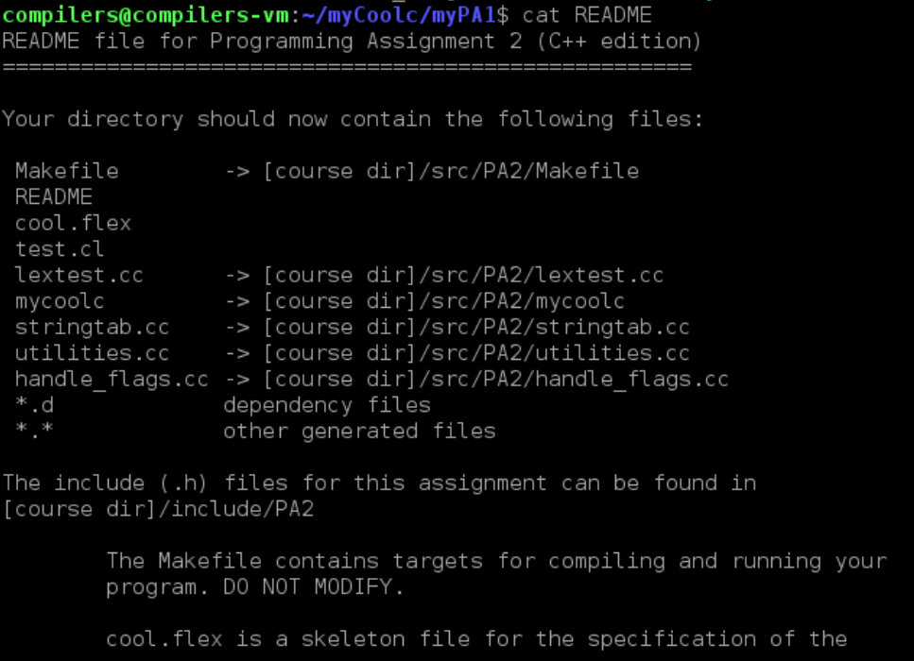

1. What you need to do is to modify file “cool.flex” and “test.cl”



“cool.flex” is a skeleton file for the specification of the lexical analyzer. You should complete it with your regular expressions, patterns and actions.

“test.cl” is a COOL program that you can test the lexical analyzer on. It contains some errors, so it won't compile with coolc.

However, test.cl does not exercise all lexical constructs of COOL and part of your assignment is to rewrite test.cl with a complete set of tests for your lexical analyzer.

Before you do any modification, although these files are incomplete as given, the lexer does compile and run.

1. Build the lexer and run it.

To compile the lexer, type command “make lexer”

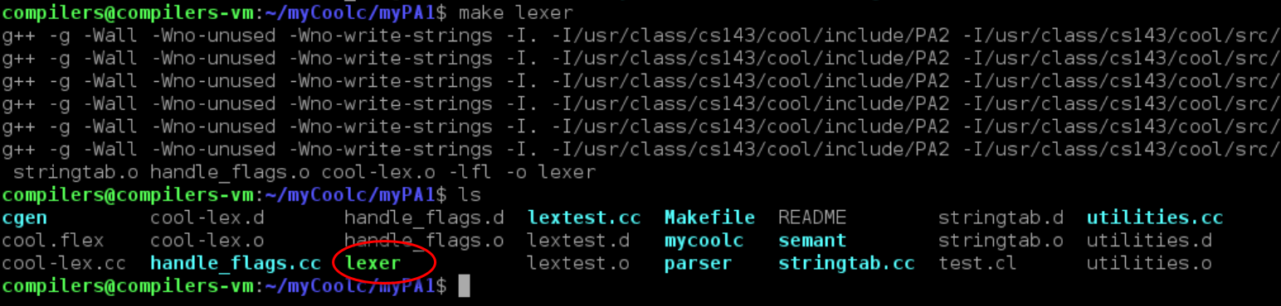

You will find file “lexer” is generated. “lexer” is the lexical analyzer of Cool. When running, “lexer” need an input, that is a “.cl” file.

Let’s create a new file “foo.cl” using command “emacs fool.cl”.

Write only a double arrow symbol (=>) in “foo.cl”

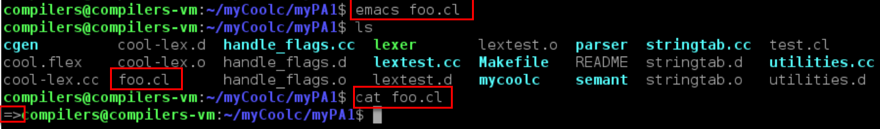

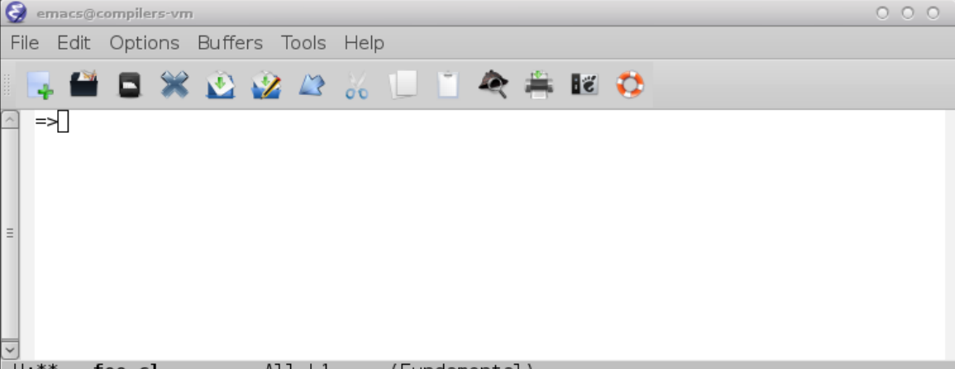

To run the lexer with input 'foo.cl' using command “./lexer foo.cl”

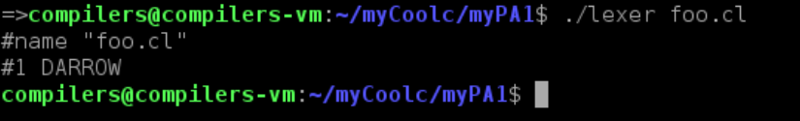

It prints out the line number and the lexeme of every token recognized by the lexical analyzer “lexer”

Form the output, we see token DARROW in “foo.cl” is recognized.

Why???

Before we do any changes to cool.flex, there is a default rule for recognizing symbol double arrow. Open file cool.flex and check it.

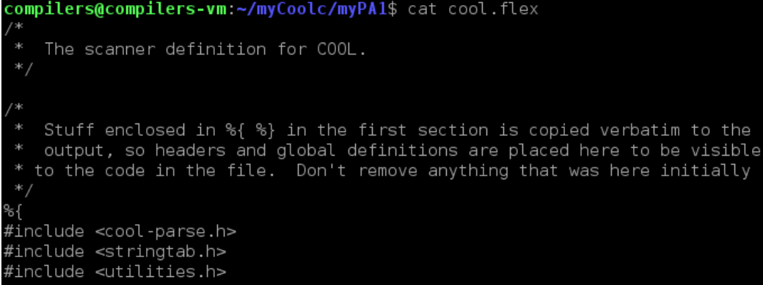

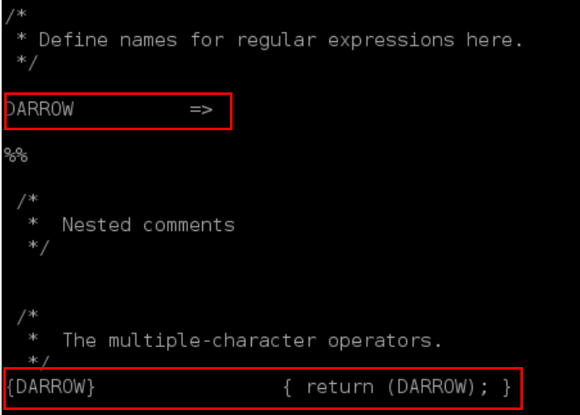

To run your “lexer” on the file “test.cl”, you can use command “make dotest”. It’s same as “./lexer test.cl”

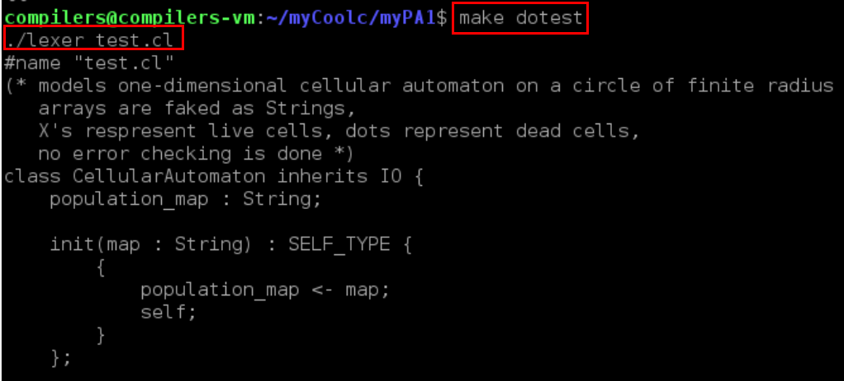

Since we haven’t do anything in file “cool.flex”, no Token is recognized.

1. Start to writing rules to file “cool.flex”.

You can follow such a loop:

* Add some rules in cool.flex
* Add the corresponding program in foo.cl
* Build the lexer by running “make lexer”
* Check the output of “./lexer foo.cl”
* IF you get the desired output, then proceed to add some more ruels in cool.flex

You can start from the simple one, the rule for Keyword, ID, and Symbols. If the lexer work correctly, then continue with rule for comments and string constants. Finally add the rules for Error handling

7）Grading your lexical analyzer.

Download the grading script and put it in the directory where the cool.flex file is.

The command for downloading grading script is:

“wget https://courses.edx.org/assets/courseware/v1/2aa4dec0c84ec3a8d91e0c1d8814452b/asset-v1:StanfordOnline+SOE.YCSCS1+1T2020+type@asset+block/pa1-grading.pl”

This should save the script file pa1-grading.pl in the folder.

But you may encounter an error and cannot download the “pa1-grading.pl” successfully.

Then just copy the file “pa1-grading.pl” the teacher given to the fold where the cool.flex file is.

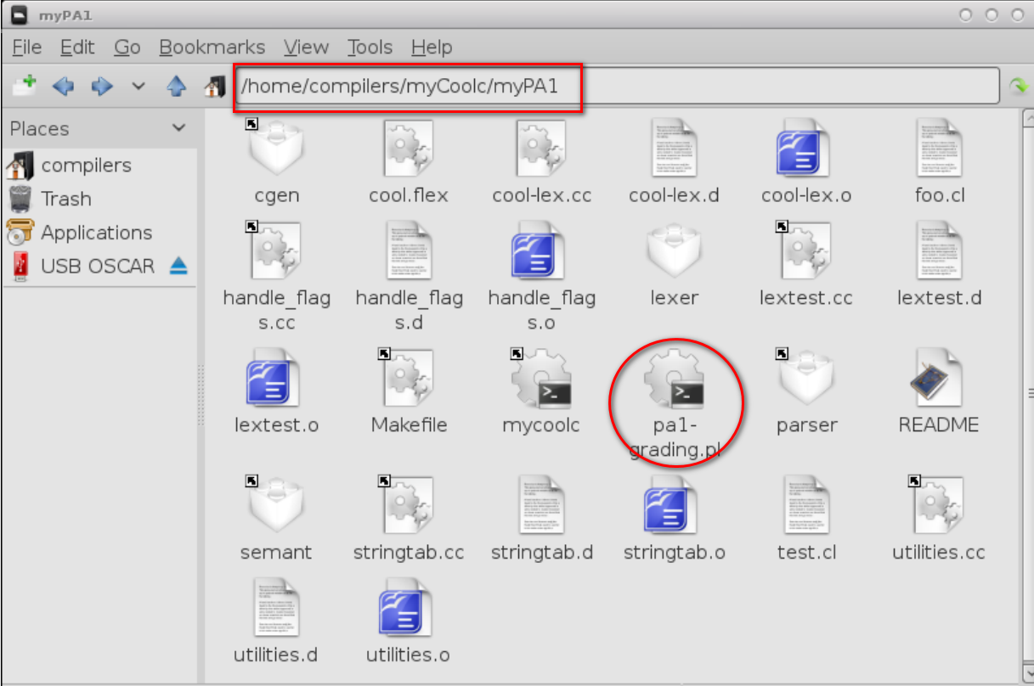

. 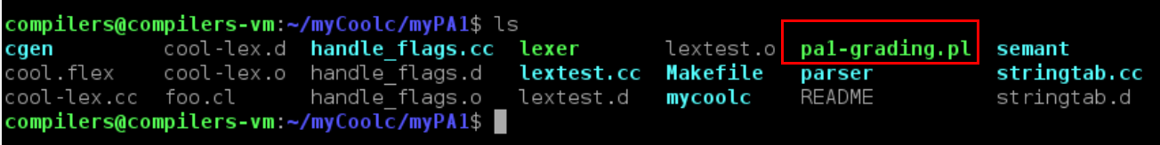

Run the grading script using command “perl pa1-grading.pl”

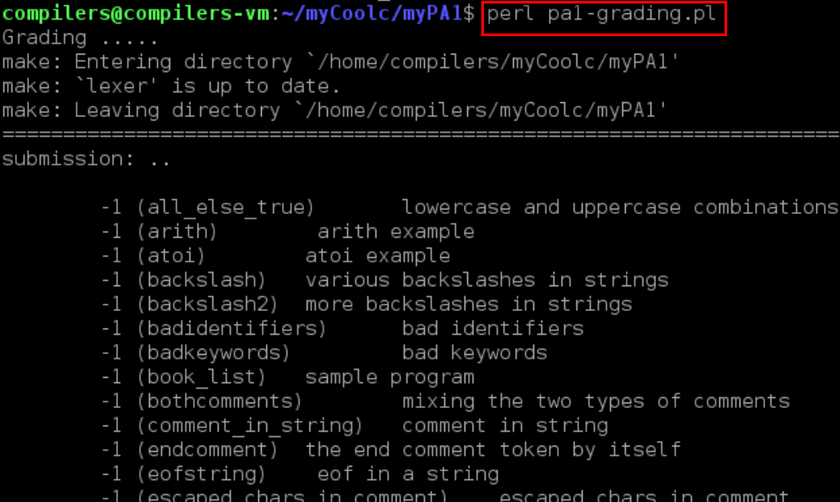

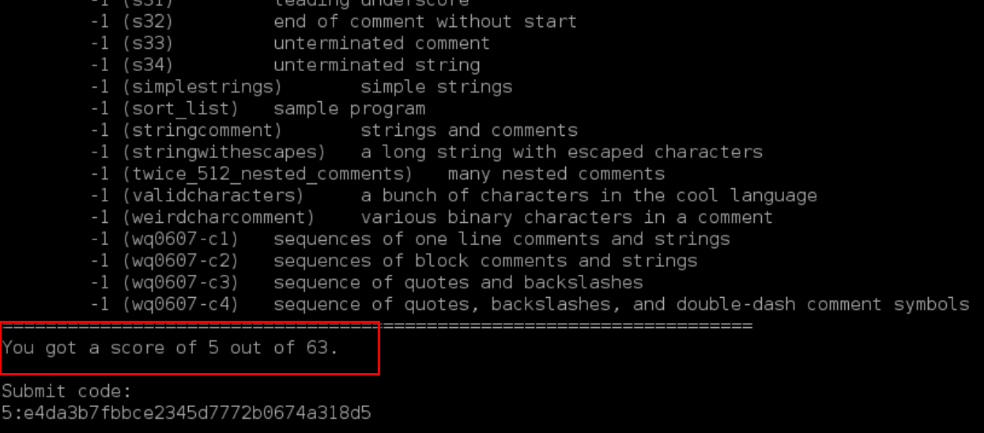

The script will give you a grade at the end.

Once you are satisfied with your grade, you can submit your result.

1. Submit your result.

* You are required to submit your cool.flex file, together with your experiment report.
* Name your cool.flex as学号+姓名+cool.flex
* Name your report as 学号+姓名+Experiment1.docx
* When preparing your experiment report, follow the “Experiment Report Template.docx”

To do this assignment, you need to know about flex. Flex allows you to implement a lexical analyzer by writing rules that match on user-defined regular expressions and performing a specified action for each matched pattern.

You can consult “Other Project Resources” on the course website.

